**5. Lo-Fi Prototypes**

* Idea #1- Simple Task
  + Description- A checklist where students can add self-care activities, and check them off when they are completed.

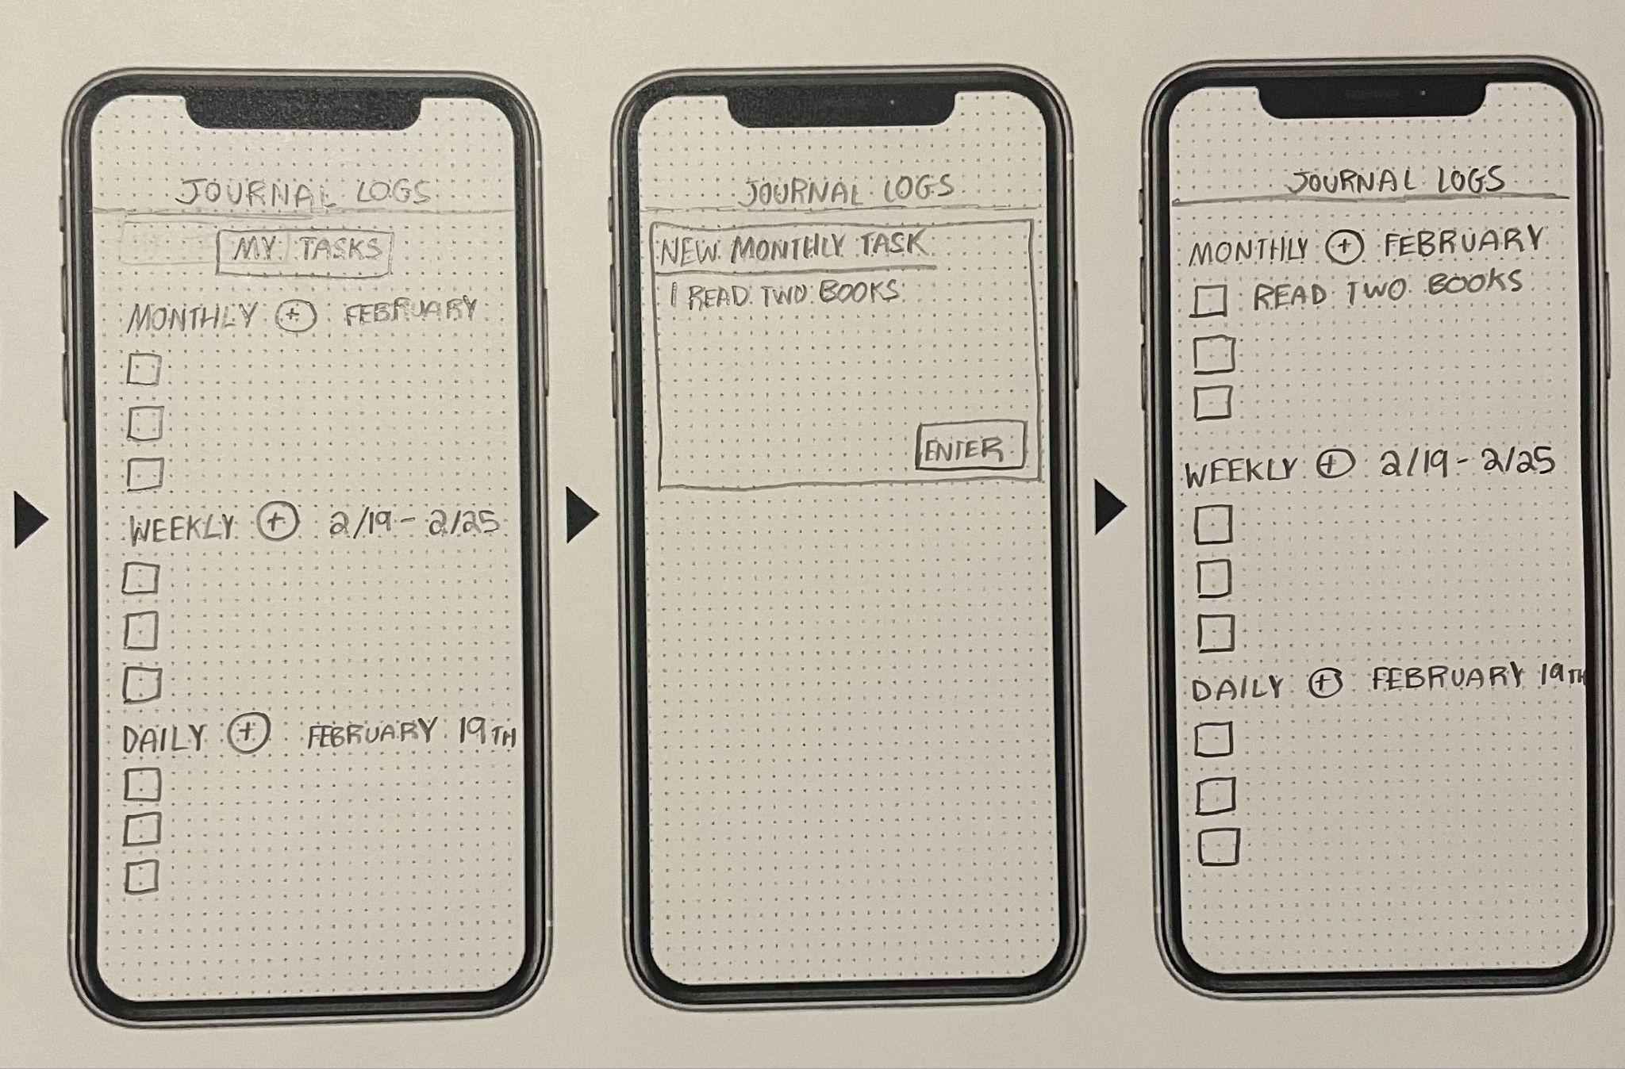

* Idea #1- Medium Task
  + Description- A guide for students to see recommended self-care activities and to create/check off their own self-care tasks

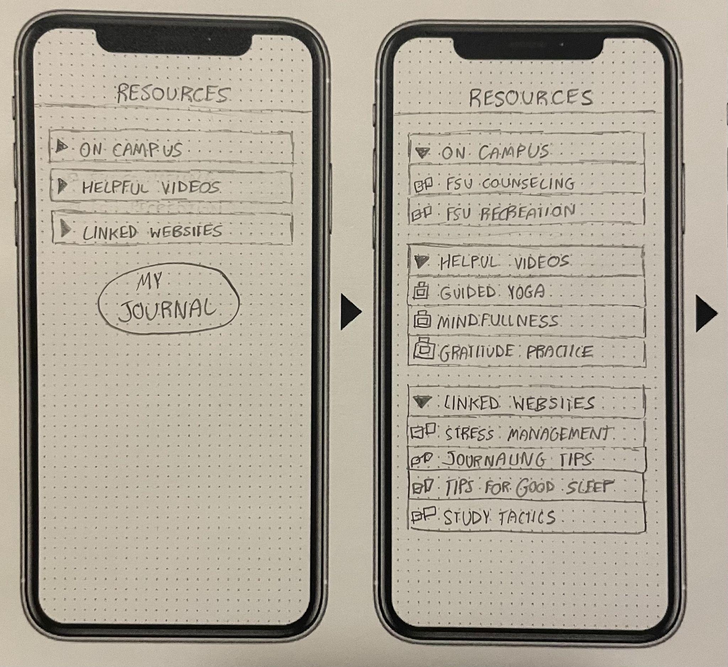



* Idea #1- Complex Task
  + Description- An interactive college Canvas “course” that students can use to track their self-care tasks, find direct links to self-care resources, and have access to announcements that highlight helpful on-campus events.

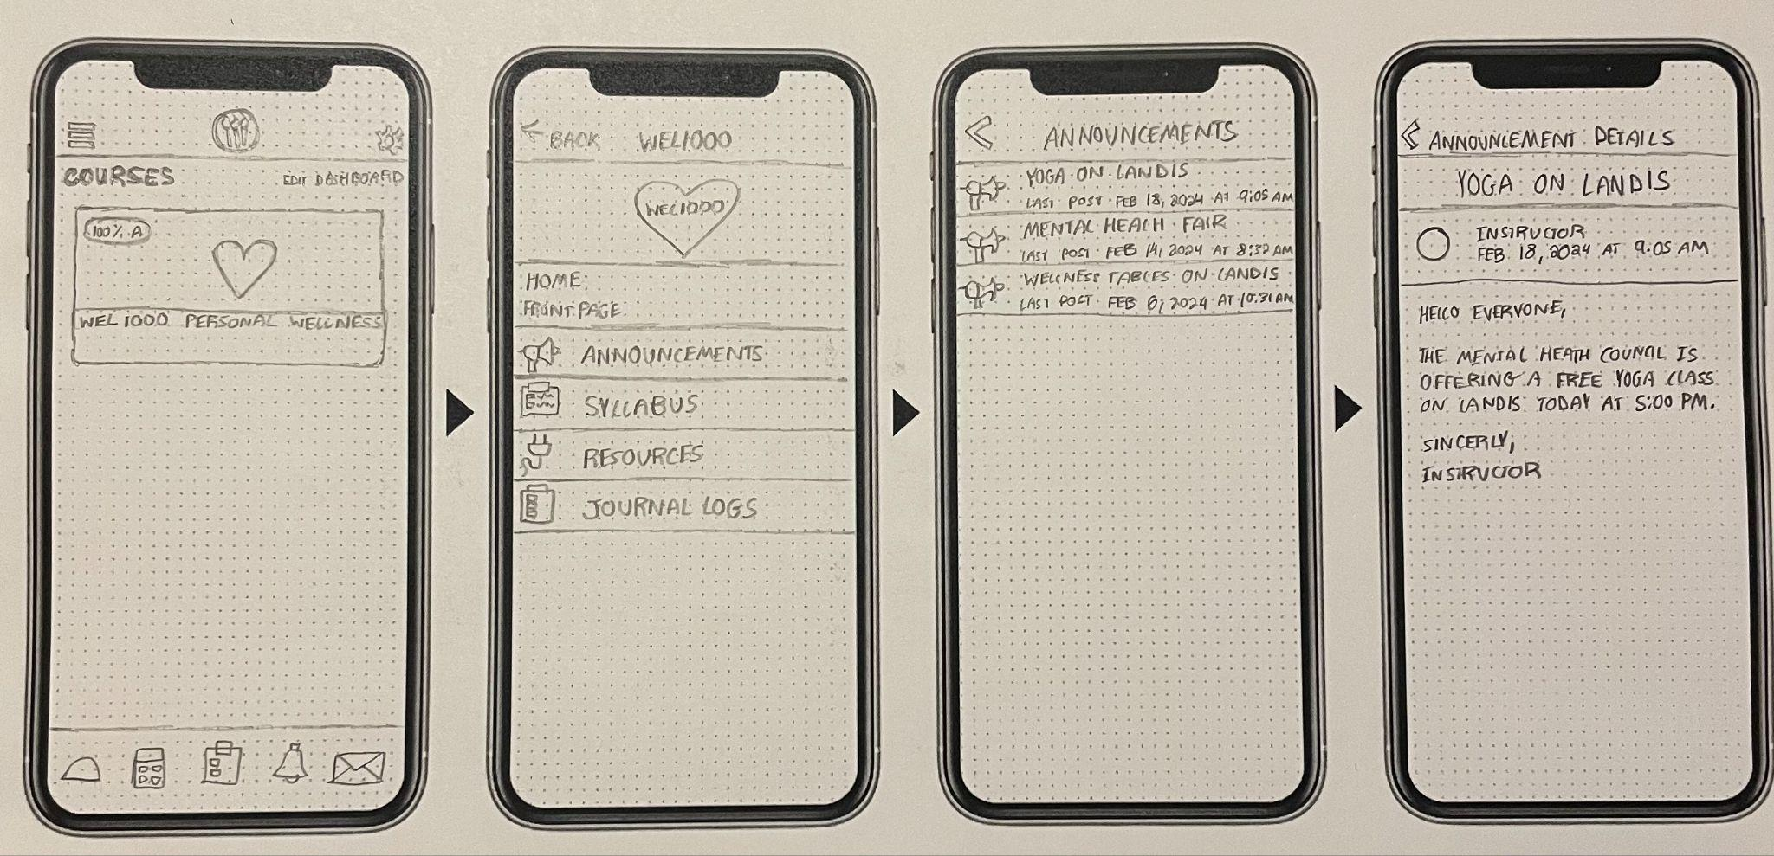

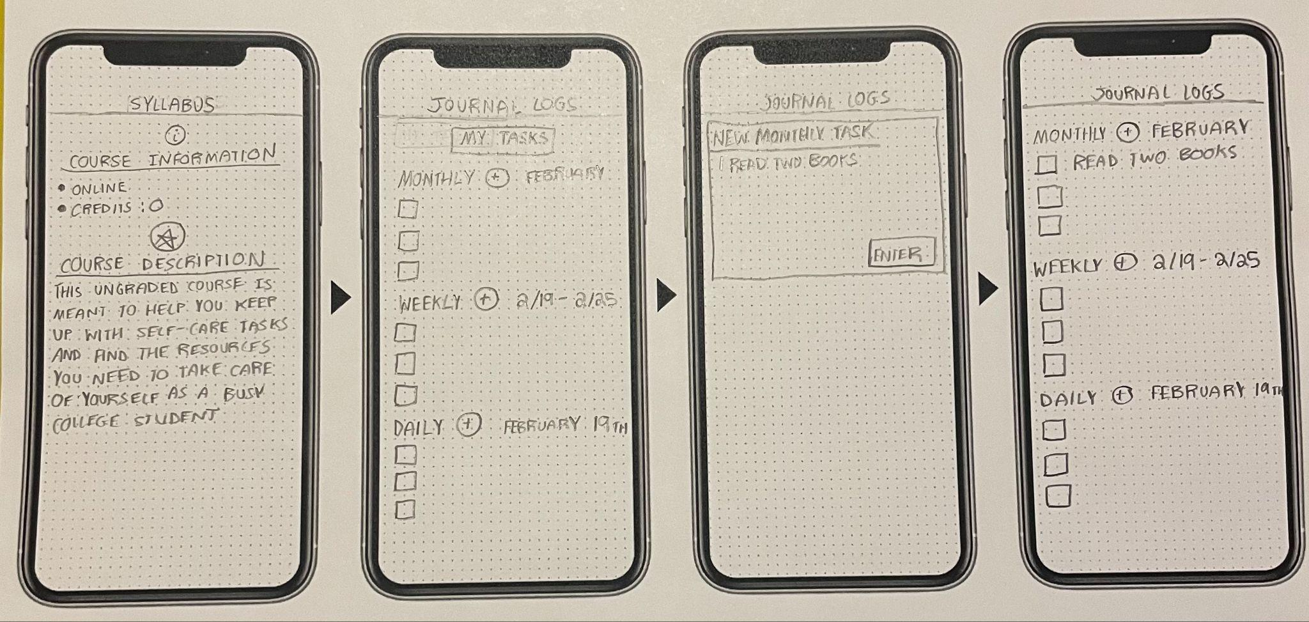

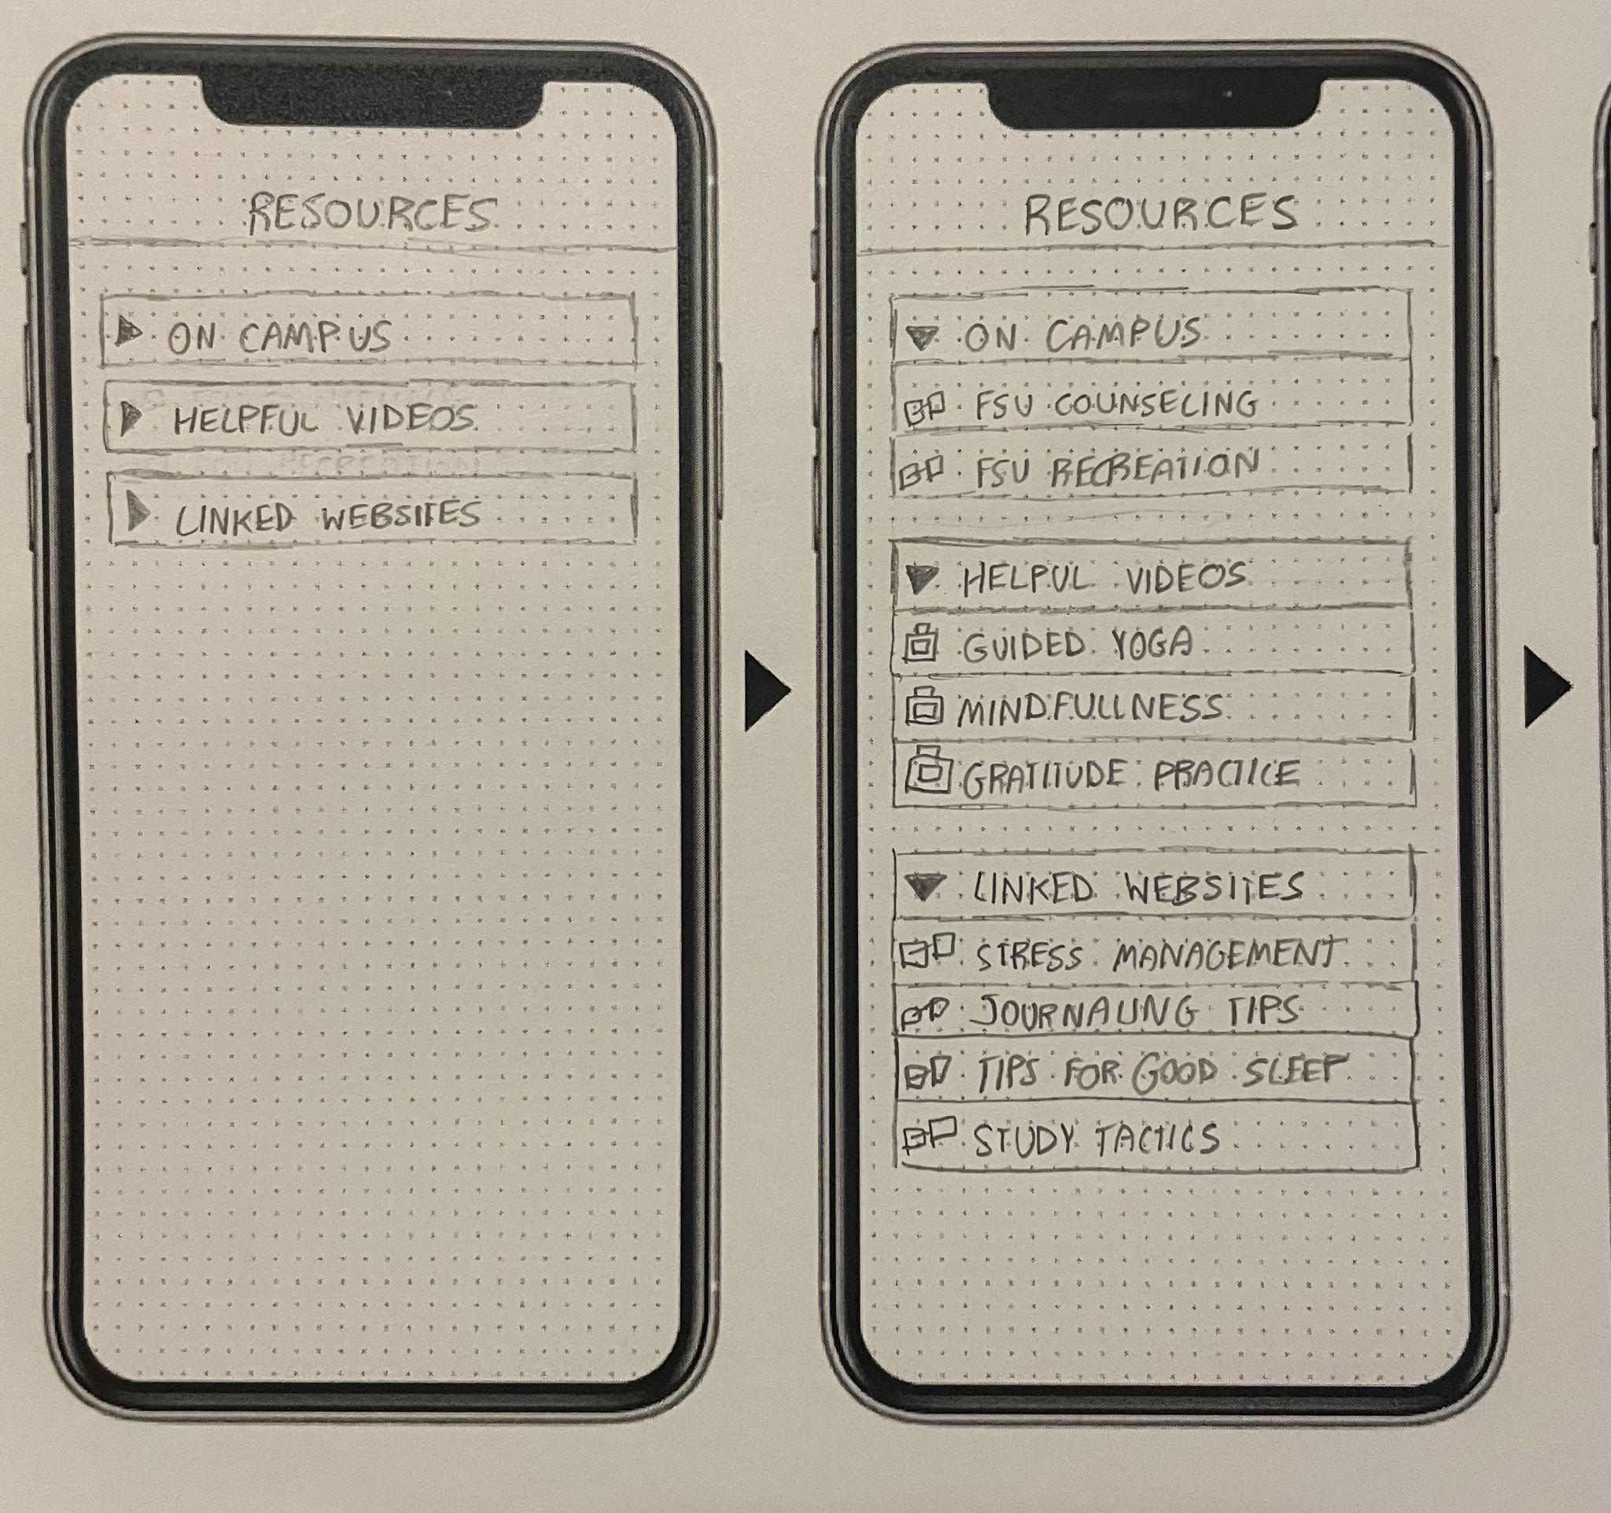

* Idea #2- Simple Task
  + Description- Creating a system by which users can create new journal tasks and upload them to a digital planner.

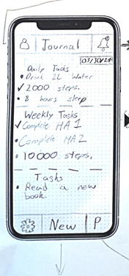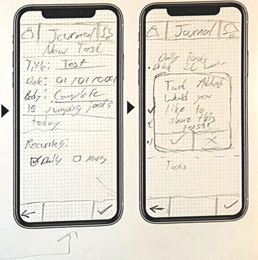

* Idea #2- Medium Task
  + Description- Allowing for users to share messages and tasks to each other through a standalone application.

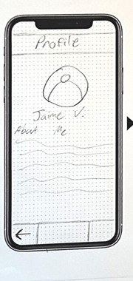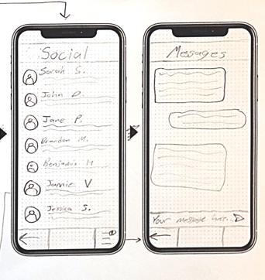

* Idea #2- Complex Task
  + Description- Create a standalone app that allows for users to journal in a social manner by sharing journaling options with their peers.

